DEVELOPMENT  Based on the ‘slow food’ movement ideas:  - Savouring food and company  - Using local – home grown ingredients  - Building a longer table – inclusive  - Cooking together  - Conversation/dialogue  April’s vision  Music tour with musicians on bicycles on the Kettle Valley Railway grade in interior BC, carrying instruments on backs; local produce and wines in their panniers. Camping and connecting with communities in old village halls, schools, community centres, historic churches. Workshops on ecology or other issues, jams, communal meals, concerts. Supported by group travelling with tour in electric vehicles to pitch tents, do logistics etc. Sponsored possibly by wineries on the route.  Design evolved with lots of conversations and an unreleased CD | Aspects of SLOW TOUR  - Seeking connections, more time in communities- with community groups, musicians providing role models of inclusion, good human relations, implicit support of pro-social actions, top notch music; enjoyment for everybody  - Less travel for musicians daily. Alternate transport, regional view  - Workshops-Deepen knowledge of issues, techniques, local / regional specialities  - Align with non profits, community based organizations  - Jams- before concerts, include jammers in concerts sometimes  - CD releases  ACTION  COLORADO SLOW TOUR  - Anti-ageist  - Learned songs of other generations  - Produced Spotify list of songs for other musicians  - Brought dementia music specialist Hanna Doreen Brown  - Partnered with Make | - A Wish foundation to finish songs with elder songwriter  - Workshops, sing a longs, parties, mini-concerts in centres and facilities, meals  - Colorado’s Music District deTour  - Video /audio record  - Evening Concerts in regular venues  Courtney says:  From our @coloradodetour thus far. Before our evening shows @taylorashton and I have spent the afternoon singing at elderly centres. I think I have fallen in love with someone at every place we’ve played – watching eyes light up as old lyrics come to mind is just too much.  Our new friend Polly squeezed my hand and while we sang “Let Me Call You Sweetheart”. ‘A moment ago I cried because my husband used to sing that to me from across the house’. My heart.  Taylor says:  We put together a Spotify  playlist of some of the old and slightly less old songs we learned especially for the occasion, including my favourite  “ Let Me Call You Sweetheart ”. I had never heard it before, but we played it every day after a sweet elderly lady sang it to us a capella, at our first visit. It is such a strong, beautiful and tender melody. Hearing the chorus of voices all around the room join in as they recalled the song, was like being on a ship slowly turning a corner, to watch a monumental 200 year old iron bridge come into view.
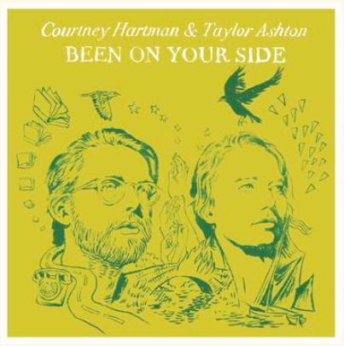
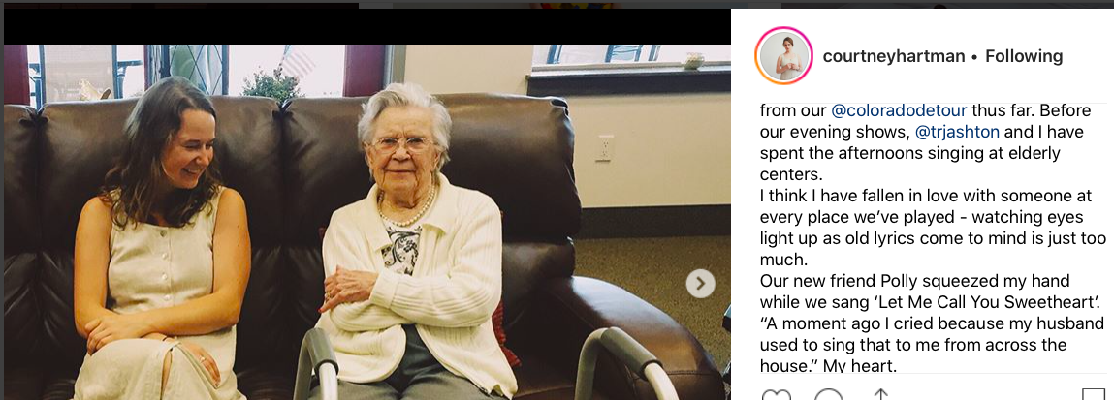
https://freedirt.net/products/courtney-hartman-taylor-ashton-been-on-your-side

\

Articles on Slow Tour
https://www.westword.com/music/courtney-hartman-and-taylor-ashton-tour-music-through-retirement-communities-10739685?fbclid=IwAR1GC3EJg3tBkbdggskBBsoW3xXIJmaStcXPHbhqXqU_aRwCVVqeRkyv4Xo

http://www.gratefulweb.com/articles/courtney-hartman-taylor-ashton-embark-innovative-tour-colorado

Reviews of CD
https://www.folkalley.com/album-review/2018/album-review-courtney-hartman-taylor-ashton-been-on-your-side

http://americansongwriter.com/2018/08/courtney-hartman-taylor-ashton-preview-new-lp-first-us/

Courtney’s articles and writing
https://medium.com/@courtneyhartman

http://heroinchic.weebly.com/blog/poems-from-the-way-by-courtney-hartman?fbclid=IwAR3-Iw93mgNoeDXtdKvFso1csDX1FTXTC_yCeVMMTqfzBeuf2DxG9aUdqr0

Video Clip links
Courtney
https://www.youtube.com/watch?v=cvxihPmbZnE

https://www.facebook.com/courtneyhartmanmusic/

https://www.facebook.com/courtneyannehartman

https://www.courtneyhartman.com

https://www.youtube.com/watch?v=oqBERd-MHH4

https://www.youtube.com/watch?v=qeiAEa7SRkE

Courtney and Taylor
https://www.youtube.com/results?search_query=courtney+hartman+and+taylor+ashton

https://www.youtube.com/watch?v=C832OUXGkWc

Taylor
https://www.youtube.com/watch?v=6okYkMjxzhA

April Struthers’ Publications
www.witworks.ca ; http://witworks.ca/downloads/
Current projects: Prevention of adult abuse – collaborative networks of response
Organizing against racism – building protocols
Responding to Reconciliation with First Nation’s communities
‘Being Least Intrusive’ cross cultural response tool
Building Action Learning Network
Developmental Evaluations
Learning Exchanges with musicians

Links to Ageism Material

http://www.nationalseniorsstrategy.ca/wp-content/uploads/2015/02/NSS-Elder-Abuse-Social-Isolation.pdf

http://www.ageismore.com/about/are-you-age-aware

reveraliving.com

http://dx.doi.org/10.2471/BLT.17.202424

https://nyceac.org/countering-ageism/

