Isolation Commission | 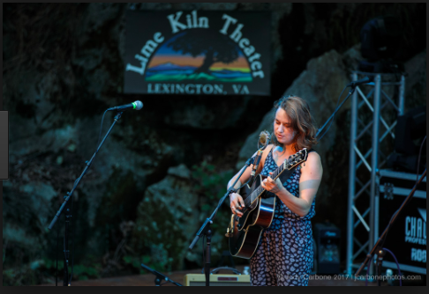
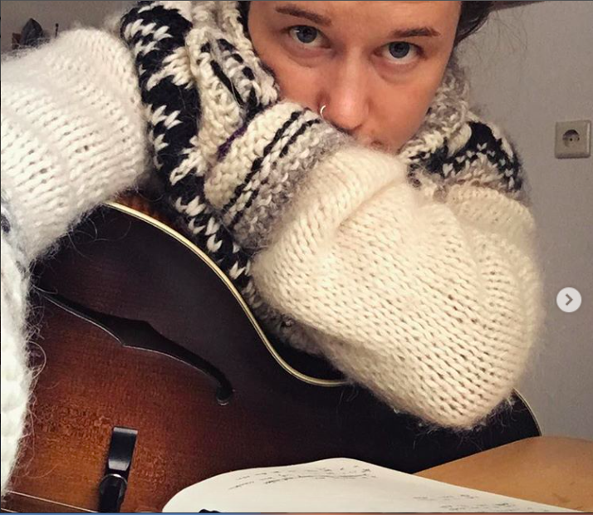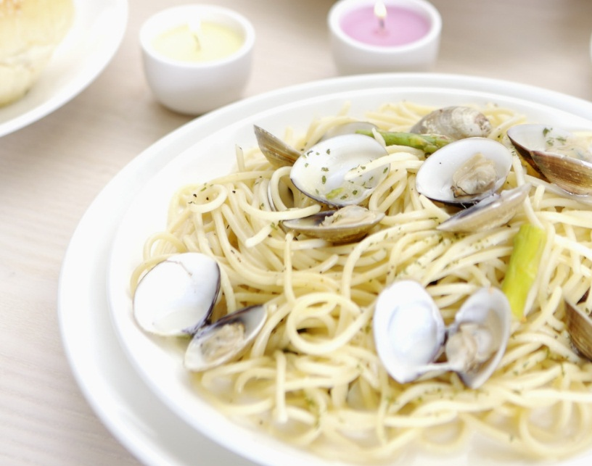 | 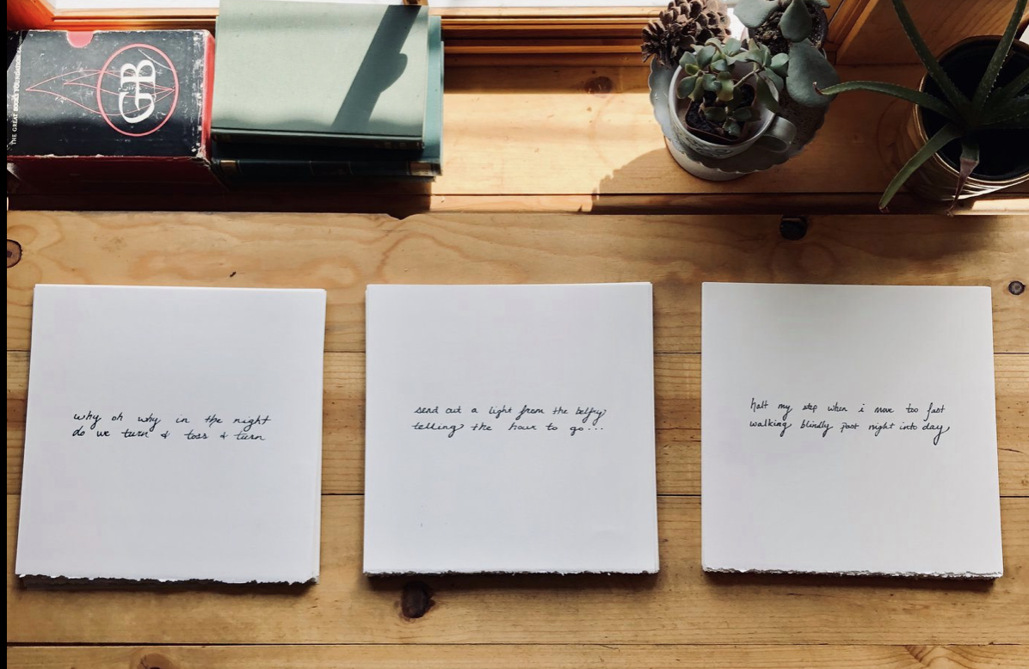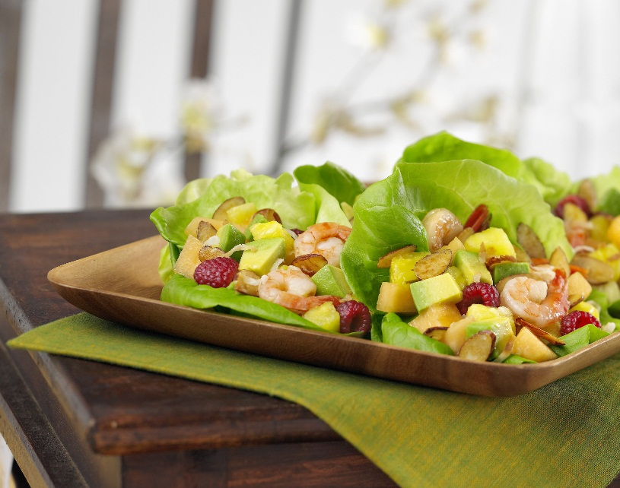

  - Music in the time of COVID
Continuing lively musical experiences through physical distance

Commission an Original Piece
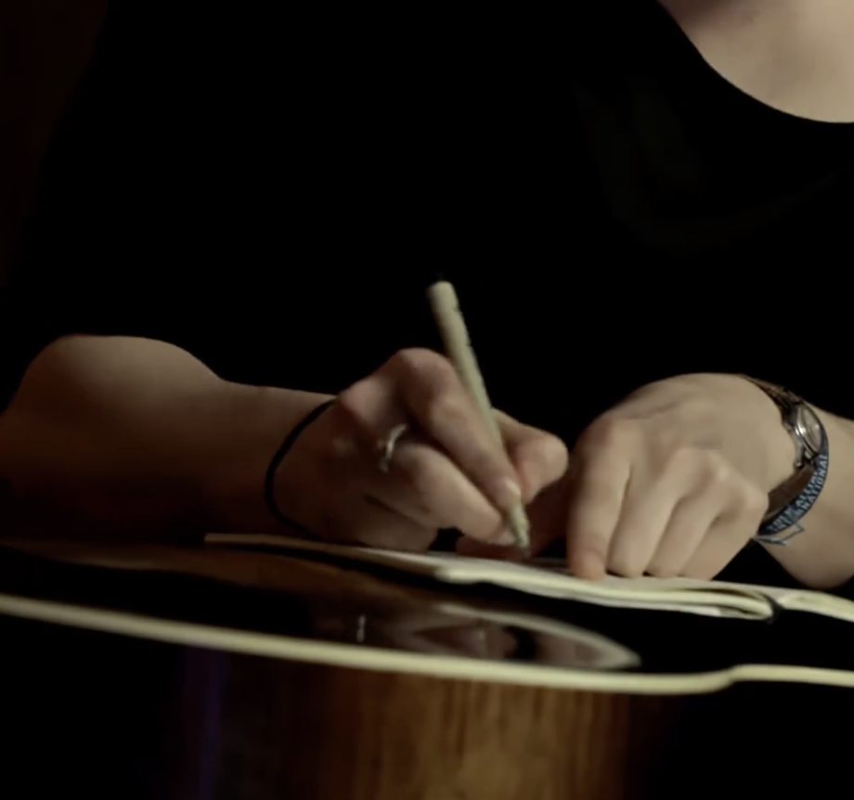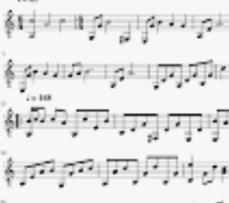 “A distinctive guitar stylist...
and a songwriter that delights and disturbs.” Acoustic Guitar Magazine

Commission
A song, conversation with a songwriter, recording or short written piece. April Struthers in Canada asked for a song with handwritten lyric sheets, and a ZOOM personal concert. “I’ve been captured by Courtney’s lyrics and deep, tasteful musicality, and stunning guitar work. What an opportunity this is to order up something for myself. Physical isolation, but emotional connection.”
Bio
Courtney Hartman is an American songwriter, guitarist and singer who began on the fiddle, picking up the guitar at the age of eight. After studying on scholarship in the American Roots Program at Berklee College of Music in Boston, she toured with Rounder records quintet, Della Mae. She has since visited 30 countries and earned a Grammy nomination for the 2013 album This World Oft Can Be. She has worked with Mike Campbell, Buffy Sainte-Marie, Bryan Sutton and many others. The Fretboard Journal heralded her as ‘easily one of the greatest flatpicking guitarists performing today.’ Celebrated for her musicianship and creativity, she has been called ‘an extraordinary guitarist and fluid inventive improviser’. Courtney has been a OneBeat fellow, and this year contributed music to the PBS documentary H20, as well as releasing a solo album “Ready Reckoner”.

Contact Me
e: courtneyhartmanmusic@gmail.com
w: www.courtneyhartman.com
p: 307-710-6383
