Critical Incident Response

Protocol for Organizing against Racism and Hate

Sunshine Coast
2017

Contents

Acknowledgements 4

Preamble 5

“Is there a problem on The Sunshine Coast ?” 7

Community Responses 10

The Broader National Picture 11

What is a “Critical Incident”? 12

Definition of both the issues and examples of a Critical Incident 13

Purpose of Response Protocol 15

Continuum of Response 16

Issues Emerging Through Social Media Use 17

Advocacy-Assessment Steps 17

Agency Services 19

Sunshine Coast Critical Incident Response Protocol 20

Tables & Charts
Sunshine Coast Statistics 23
CHART 1 Visible Minorities 24
CHART 2 Age Distribution 24
CHART 3 Religious Affiliation 24

Appendix A Text of the Protocol 27

Appendix B Governments, Boards, Agencies, Organizations and Groups 28

Appendix C Text of the District of Sechelt Vision and Sunshine Coast Community Accord (Charter Of Dignity, Respect, & Acceptance) 29

Appendix D Links to the Statutory Provisions: 31
Universal Declaration of Human Rights Canadian Charter of Rights and Freedoms
Canadian Human Rights Code (applicable in federal jurisdictions)
British Columbia Human Rights Code

Appendix E Glossary of Terms

We gratefully acknowledge the financial support of the Province of British Columbia
Through the Ministry of International Trade



Acknowledgements

The Sunshine Coast Critical Incident Response Protocol Project would like to acknowledge the financial assistance and advisory support of the Ministry of International Trade and Responsible for Asia Pacific Strategy and Multiculturalism BC Anti-racism and Multiculturalism Programme.

The Critical Incident Response protocol is in draft form and will be adopted when signatories are officially ratified, and celebrated in a Community Event.

We would like to thank all the participating individuals, organizations, and agencies who have demonstrated a real commitment to the work on the Protocol, and those who have become engaged in the work towards the development of the Sunshine Coast Critical Incident Response Protocol – whether by participating in person at meetings, responding to drafts, via electronic consultation, or through phone conversations. Their gifts of time and insight have contributed immensely to this work.

Thanks to the Comox Valley Centre for Community Justice for its leadership, and sharing of its protocol, and permission to use extracts in this document. To address the issues of social media as a tool of discrimination, we would like to thank Sheldon Falk who researched the problem and developed text / response around the issue on behalf of the Comox Valley Centre for Community Justice.

Finally, we would like to thank each of the signatories to this protocol – their commitment to a better world and a more compassionate community in the Sunshine Coast is their own reward.

This draft was prepared by April Struthers of Wit Works Ltd, under funding from and contracted by, EmbraceBC. The OARH Committee of the Sunshine Coast contributed time, suggestions, local examples and on ongoing commitment to work around the issues of racism and hate.

Cpl. Kris Josephson, RCMP
LeeAnn Johnson
Lucie McKiernan
Ian McDonald
Jane McDonald
John Denham
Nancy Denham
Sandy Middleton
Maria Giltrow

Preamble

Racist remarks, homo/transphobic comments, religious epithets, ethnic slurs – they all arise from strongly held negative feelings about others, and from thoughtless actions that betray a lack of capacity to prevent such feelings from being publicly expressed. Such sentiments often arise from a need to express an internal sense of rage that is rooted in irrational thoughts and feelings or a sense of being harmed by the mere existence of those who exhibit “otherness”. Racist, homo/transphobic and hate-based behaviours, actions and incidents undermine the very core of what it means to be a community. They threaten the health and safety of communities.

Such incidents require a response from the community that asserts community beliefs in democratic freedoms, individual rights, and community responsibility. On the one hand, an ineffective response to such incidents suggests public acceptance of those underlying views and may even encourage subsequent “copy-cat” incidents by others holding similar beliefs. On the other hand, when such incidents are effectively responded to, and those involved receive the support and assistance needed to overcome the causes and effects, it sends a clear message to the community that such behaviour is not acceptable in Sunshine Coast. It also proclaims the message that this community is prepared to help the individuals involved to transform those feelings and actions into something positive that contributes to a healthy community for all.

The Critical Incident Response Protocol directly states the Sunshine Coast’s desire to establish and maintain a community of acceptance and understanding that welcomes and affirms our diversity of culture, religious belief, ethnic background, differential ability, age (particularly youth and elders) groups, sexual orientation, and socio-economic status. Accepting, affirming, and diversity-rich communities contain within themselves the seeds of their own success. They embody the flexibility needed to overcome the many challenges that arise and strain the relationships among, between and within the various sectors of the community. The strength that comes from diversity enhances the lived experience of community for everyone.

Three Pillars of Action in responding to Incidents

In working to bring the community together around issues related to racism, homo/transphobia, and hate-based incidents, we have adapted from other communities who have worked in the area in the past, the strategy of the Three Pillars of Action:

Awareness - an ongoing public educational commitment by the parties to the protocol that promotes an understanding of the values of acceptance and the positive role of diversity in the life of all Coast residents. The range of educational modes should include formal educational measures in the schools, artistic and cultural programmes expressing the concepts, ongoing articles and items in the public media, and the expression of these ideas in a positive light by politicians and elected officials in community meetings and other gatherings.

Prevention - promoted through cross-cultural educational initiatives carried out consistently throughout the school district over a period of years providing the next generation and newly arrived individuals and families with a tolerant and diversity-affirming belief structure that incorporates a wide understanding and appreciation of the cultures and ethnic diversity represented within our population.

Response - the protocol **reflects a consistent, Coast wide, agreement by cultural and educational institutions, municipal governments, First Nations governments, the business community, and service organizations on how each will respond to the occurrence of a critical incident involving racism, homophobia, or other hate-based event.

The protocol contains several resources, including broad-based policy frameworks for bodies with legislative/governance authority; simplified conflict resolution processes applicable within the small business and non-profit organizational environment; and specific techniques, skills and services which may be accessed by persons who sign onto the protocol in an individual leadership capacity. These techniques and skills will allow individuals to effectively confront critical incidents in their daily lives through being “active witnesses” to such incidents and a set of appropriate actions they may take in the moment.

The commitment of the signatories to the Protocol, together with concerted actions undertaken by our partner groups and organizations, can and will lead to a positive and welcoming climate of acceptance and understanding throughout the Sunshine Coast. The benefits for residents, organizations, and businesses will enhance the total package of elements that have made the Sunshine Coast a vibrant, exciting, and engaging community in which to live together and raise our families.
** Once signed by the wider community

Is there still a problem with THAT here?

Conversations with First Nations and other visible minority residents often reveal painful stories of verbal and emotional assaults being experienced during the course of ordinary interactions with the dominant culture. As well, residents who do not belong to visible minority groups, but who have unique differences such as accents from different or other cultures and such like signifiers also share stories of xenophobic and homophobic verbal insults in their daily life. The results of these experiences often lead to withdrawal and isolation from the community they have moved to in hopes for a new life. These actions and behaviours are not consonant with the reputation for openness and fairness for which Canada, and the Sunshine Coast is internationally known.

Research was completed for a OARH project on the Sunshine Coast in 2010, with focus groups of minority and self identified marginalized groups, faith groups, youth, and others:

Type of Focus Group | Location | # of participants | Interested in further activity
Older Adults | Roberts Creek | 5 | Yes
Older Adults/Faith Group | Sechelt/Half Moon Bay | 6 | Yes
Youth Action Workers | Coast | 3 | Yes
Lesbian, Gay, Bi-Sexual, TransGender Group | Coast | 7 | Yes
ESL | Gibsons | 4 | Yes
ESL | Sechelt/Half Moon Bay | 3 | Yes
Mental Health/ Substance Abuse | Whole Coast | 7 | Yes
Faith Group | Roberts Creek/Coast | 7 | Yes
Social Planning Council | Coast | 3 | Yes

They identified discrimination based on the following ‘isms’:

- Ageism
- Racism
- Homophobia
- Geographic (location on Coast)
- Faith / religious
- Coastism (Length of residency on the Coast)
- Body shape or size
- Differently abled ‘ism’
- Genderism
- Economic ‘ism’ (employed, SA, WP)
- Mental Wellness ’ism’
- ‘American-ism”

While the labelling differed, the same dynamic of creating conditions of ‘others’ being less than ; seemed to hold true for any of the ‘isms’.

It seems that any difference can trigger discrimination.

Bullying and social ignoring underlie discriminatory behavior;
  - They are seen as dynamics that underlies all discrimination and the way it is expressed
  - They defined as negative actions or words to another because the other is perceived as different. Any group will do.
  - A part is played by the intergenerational transfer of attitudes, especially of parents to children; keeping negative attitudes in society

Members of the groups interviewed indicated that the consequences of being labeled often were harsh and may have effected being served as a customer in local businesses and affected job opportunities. Clashes between youth from different locations on the Coast resulted in assaults.

Both participants in groups and those who attended forums to publicize results of the research were relieved to have their experience of discrimination acknowledged, citizens expressed relief at having incidents brought to public knowledge, and to have their feelings affirmed that there was discrimination which had previously been denied or suppressed locally.

CONTINUUM OF VIOLENCE

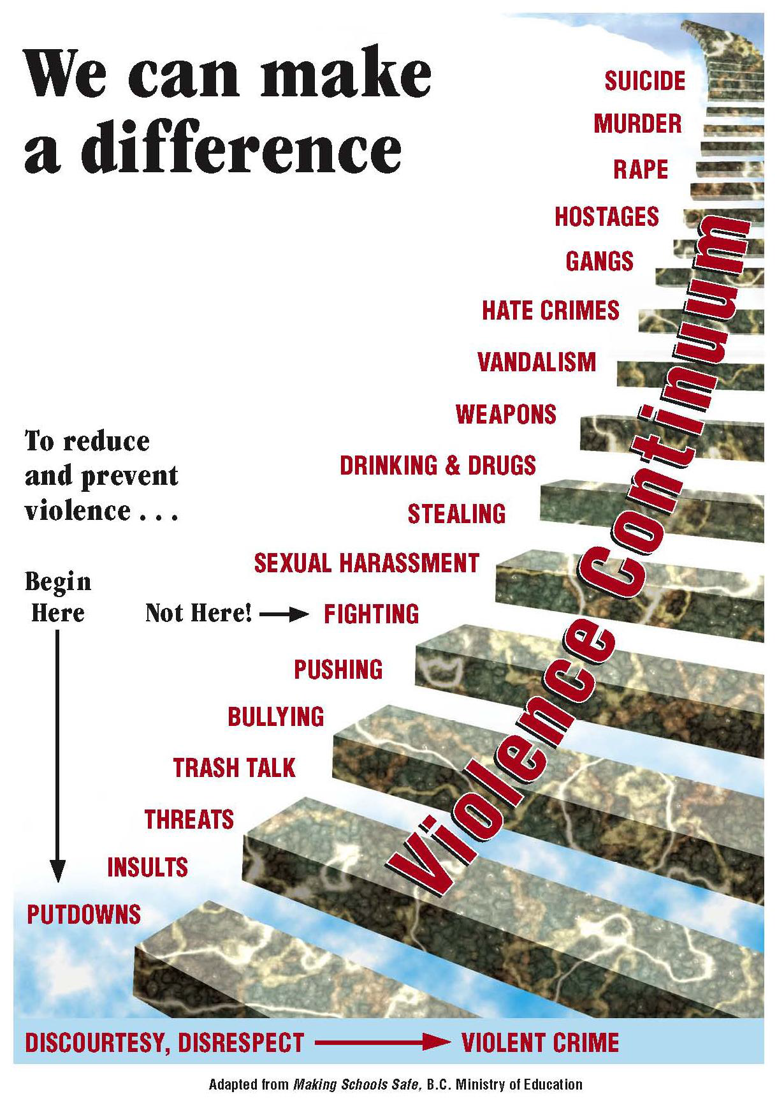

The Sunshine Coast and Successes

Sunshine Coast Community Responses to Issues of Racism / Hate

Best Practices in prevention literature shows that having coordinated community responses to attitudes and behaviours which might be socially negative, is a powerful force.

An example of co-ordinated community response is in the area of public education and community expression of disapproval and rejection of discriminatory actions of any kind. The Sunshine Coast has had a series of dialogues, initiatives, and events, to counter possible and actual critical incidents (at the awareness and prevention levels):

- Faces of Sechelt – District of Sechelt
- Accessibility Projects and Age Friendly Projects
- Community Dialogues
- Faith Based Initiatives
- Truth and Reconciliation Events
- Diversity Film Festivals
- Mindfulness Training (SD 46/Health Canada)
- Welcoming Communities’ Events and Settlement Programs
- ESL/Literacy Programs for Newcomers

The research in 2010 uncovered what participants felt would be most effective in responses:

Community “Assets” which can aid in creating a civil society include:

- Community feeling, Size of communities
- Community centers, libraries, neutral public spaces
- Festivals and (multi cultural) community events/ dinners
- Number of interest groups
- Support groups
- Faith communities who work towards tolerance /
acceptance of all
- Unions (workers rights regardless of ‘isms’)
- Retired population with time, skills, positive attitudes and resources
- Mindfulness, Harmlessness training
- Organizations living the anti-ism policies
- Youth Action Committee
- Aboriginal SD46 Programs
- DOS/SCCSS (local government)

The Broader, National Picture

Nationally, research has shown that negative attitudes based on race, religion, skin colour, and other visible markers of difference are widely shared in the population. For First Nations, these underlying negative attitudes towards them result in a lived experience that falls far short of the myths and stories the dominant culture tells itself and its children. According to a 2003 Ekos survey, 46% of Aboriginal people living off-reserve reported being a victim of racism or discrimination at least once over the previous 2 years. Research by Ipsos-Reid (2002) suggested that more than 6-out-of-10 Canadians think that racism separates Aboriginal peoples from the rest of society. Roughly the same proportion (59%) felt that Aboriginal peoples are discriminated against by other Canadians. There are increasing anecdotal references to conflict between Aboriginal and non-Aboriginal children and youth. Overall, most residents experience their life in this community as friendly and accepting, which contributes to a general sense that “there really isn’t a problem here”. The contrary evidence of lives lived in the shadow of fear or offensive attitudes or comments, is invisible and, therefore, simply is not part of the common perception. When the evidence is “out of sight”, it is also “out of mind”. A poll conducted in June, 2007, points to this kind of a contradiction. It found that 60% of Canadians believe minorities should try to fit the traditionally Canadian mold, but on the other hand, 40% of people said it should be a higher priority to encourage Canadians as a whole to try to accept minority groups and their customs and language. 82% of those polled agreed with the statement
that: “Canada’s multicultural makeup is one of the best things about this country”.
(Source: Comox Valley Centre for Community Justice)

Demographic Makeup of the Sunshine Coast

For the most part, the statistical data from the 2011 Stats Can Census support the view that the Sunshine Coast is a relatively homogeneous community composed of a majority of residents descending from the Western European cultures. The data in Table 1 and in charts 1 - 3 confirm that racially the Coast is overwhelmingly white (4.6 % report visible minority status), older in age (51.6 % above median age in BC , versus 41.9% in other parts o the Province), and predominantly Christian when identifying a religious orientation (40 % report Catholic, Protestant, or other Christian). A total of 1.7 % reported themselves as being from faith groups other than Christian. Notably, 54 % of Sunshine Coast residents reported that they held no denominational religious belief – at least some of whom are likely part of BC’s “spiritual but not religious” affiliation, the largest in Canada.

As noted in the OARH Protocol for the Sunshine Coast:

“What is not reported in these data are other criteria upon which intolerance may be based, such as visible physical disability, socio-economic status, class, age, mental disability, etc. Conversation in school hallways and in the malls provides

ample evidence that residents of the Sunshine Coast are equally capable of applying epithets based on these criteria in expressing their insensitivity and intolerance. “

What is a “Critical Incident”?

In the context of our work, The Critical Incident Protocol has adopted a definition of the kind of incidents that we believe need to be addressed on a community-wide basis.

Clearly some incidents would fall under the scope of Section 319 of the Criminal Code, and hence would be properly reported to the RCMP, while others constitute a deep disturbance in the community at large and a hindrance to the welcoming and inclusive community the Sunshine Coast seeks to be. The latter incidents could be handled by the Restorative Justice Program of the Sunshine Coast or other community resources.

We believe, with the Ministry of Education’s Safe School Programme, that violence is part of a continuum that begins with discourteous and disrespectful communications (at the social level) and progresses to physical violence, assault, and a climate of targeted fear (at the Criminal level - See Continuum, Page 23).

We also concur with the Safe Schools Programme, that the work of preventing violence does not begin with interventions at the “fighting” stage, but much earlier at the level of a community’s permissive acceptance of a culture of disrespectful and discourteous communication.

As the University of Western Ontario Campus Community Police Service has concluded, the kind of incident to be addressed:

“... refers to a broad range of behaviours along a spectrum of severity that can generate concern for personal safety and/ or personal injury. At the low end of the spectrum are disruptive, aggressive, harassing or emotionally abusive behaviours that generate anxiety or create a climate of distrust that adversely affect process, productivity and morale. Further along the spectrum are words or other actions that are reasonably perceived to be hostile, intimidating, frightening, or threatening and generate a justifiable concern for personal safety. At the high end of the spectrum are acts of overt violence such as assault, pushing, shoving, hitting or physical actions that include weapons and serious physical attacks.”

Strategic and Effective responses
The mandate of the Critical Incident Response Protocol is the formation of a strategic and effective response to violent critical incidents, while supporting and encouraging educational interventions which address the earlier sources of such violence. We have adopted a somewhat flexible definition of a Critical Incident, in order to ensure that all signatories to the Protocol can set their policies and practices in place to recognize the harmful effects of allowing persistent and negative attitudes to continue to exist, either within their own organizations/institutions or in the community at large.

Definition of both the issues and examples of a Critical Incident

The Sunshine Coast Critical Incident Response Protocol defines a Critical Incident as:

A shocking or personally upsetting racist, homo/transphobic, or hate-based event ; based on the application of any ‘ism’ (discriminatory attitudes about groups of people); resulting in distress or harm to anyone, or a group of persons, within the community

The signatories to the Protocol are committed to the fair and effective application of the following human rights legislation (within each Act’s specific jurisdiction) throughout the Sunshine Coast:

- The Charter of Rights and Freedoms, Schedule B of The Constitution Act, 1982
- The Canadian Human Rights Act
- British Columbia Human Rights Code, [RSBC 1996] Chapter 210

Criminal Code Sections relating to Racism and Hate

In addition, the signatories are committed to the equitable enforcement of each of the three anti-hate propaganda provisions of the Criminal Code of Canada:

Section 318, Advocating Genocide
“Is to argue or urge people to kill others because of their color, race, religion or ethnic origin. Genocide means any of the following acts committed with intent to destroy in whole or in part any identifiable group namely:
• Killing members of the group, or
• Deliberately inflicting on the group conditions calculated to bring about its physical destruction.

Section 319 (1) Public Incitement of Hatred
Everyone who, by communicating statements in any public place, incites hatred against any identifiable group where such incitement is likely to lead to a breach of the peace is guilty of an offence.

Section 319 (2) Wilful Promotion of Hatred
Everyone who by communicating statements other than in private conversation, wilfully promotes hatred against any identifiable group is guilty of an offence. The Edmonton Police Service, as part of its proactive response to the emergence of hate crime in that city has developed a simple and clear definition of what counts as hate activity.

Hate Propaganda is defined as:
Any communication, poster and/or graffiti used by a person or group which promotes hatred based on race, religion, nationality or ethnic origin.

Purpose of The Critical Incident Response Protocol

The purpose of a Response protocol is to describe the community’s coordinated responses to critical incidents. A community protocol describes how, in different situations, volunteers and agencies will connect with one another to support all involved in such an event.

Continuum of Response

Just as racial, homophobic, or hate-based violence occurs within a Continuum of Violence, the possible responses of the community can also occur within a Continuum of Response.

The range proceeds from individual “active witnessing” and “response in the moment”, through an informal community conflict resolution/response through to policy-based actions by institutions and agencies, and concluding with legal recourse with response by police and potential prosecution in the courts.

Recognizing the Continuum of Violence and a Continuum of Response means that we can identify both community and individual responses appropriate to the full range of critical incidents which may be encountered, whether criminal or social.

Social and/or Criminal Acts | Community Responses
Verbal abuse – put-downs, insults, threats, trash talk, wearing clothing with offensive messages | Individuals may: confront the offensive behaviour, identifying community standards, inquire how the offender would feel if similar words were applied to them, report the events to a school principal, workplace supervisor, or community authority. Where an individual is witness to such an event, they may: be an active witness (noting details of the situation, descriptions of those involved including names if known), where safety is not at risk an individual may stand up against the abuse by identifying it as unacceptable within this community, and providing support to the victim by assisting them to report or suggesting options for their consideration. Community organizations and local governments may: fund public education programmes, undertake advertising campaigns, speak out publicly
Threats and abuse promulgated through social media | Individuals may: document the posted abuse, threat, harassment, then assess the level of threat and report it to the RCMP requesting investigation Community organizations may: identify the content author and/or victim, initiate contact in a safe, respectful manner with the individuals who posted the report on social media, use private messages to identify the best course of action to address these situations, offer resources and support, leaving it to the individual to decide what actions to pursue. and the RCMP may: undertake criminal investigation and possible referral to legal prosecution where the incident reaches the level of a criminal offence.

Bullying, pushing, fighting | Individuals may: “witness” the events making notes of essential details such as offender description or cell phone photo, content of the incident, date/time, other context information and report to police authorities; physically intervene in appropriate situations where personal safety is not likely threatened; await the outcome and tend to the victim by offering comfort, support, assistance in filing a complaint, etc. Community organizations and local governments may: adopt policies of zero tolerance for such behaviours; receive complaints and support the victim in processing the complaint; impose discipline on the offender in suitable circumstances; employees intervene where injury to self is unlikely
Published offensive comments – graffiti, posters, posting of threatening symbols/images | Individuals may: report the incident to the police authorities. If the investigating officer has completed their evidence gathering for potential court action, an individual may then cover up the offending message, remove the offending images, investigate the source and report to a community organization such the Restorative Justice Program of the Sunshine Coast. Community organizations and local governments may: as above; organize community dialogues to discuss a community response and increase understanding of the effects of tolerating such actions

Discriminatory policies and practices | Individuals may: lodge a complaint with the agency/government that adopted the policy; seek assistance and support in lodging a formal complaint under the relevant legislation or policy Community organizations and local governments may: systematically review all current policies and practices to ensure that deficiencies are identified and remedied; seek advice from experts and the affected community members
Physical harassment and assault | Individuals may: file a complaint with police authorities and Prosecutors may seek a restorative remedy through referral to the Restorative Justice Program of the Sunshine Coast, Community organizations and local governments may: respond to the victim quickly and effectively by supporting them in understanding options available and encouraging their pursuit.

Social Media Threats and Examples
The Sunshine Coast added recommendations developed by the Sunshine Coast protocol; around incidents where social media was used in a way which threatened citizens and vulnerable groups: The recommendations include encouraging Signatories and citizens to:

1. Document the Report

The first step is to document the report. The date, time, and any other details should be recorded. The documentation should include any links or downloadable content. One way to effectively document a report is to screenshot the content using a computer or mobile device. (Most computers can create a screenshot by pressing the „print screen‟ key and then pasting to another program, such as Microsoft Paint. On most mobile devices, screenshots can easily be created by holding down a combination of the volume rocker and power or home button.)

2. Identify the Level of Threat

Second, the level of threat must be identified. In the case of a report of a violent crime or of threats of violence, the RCMP should be contacted immediately. It is likely that at

this point the local authorities will take control of the investigation.

3. Identify the Content Author

If a violent crime or threat of violence has not occurred, it may be appropriate to seek to identify the user who posted the original content. Sometimes there may be a link to the user’s profile included in the post or shared content. The RCMP have a major cyber-crimes unit with expertise in social media, computer tracing, and other means of obtaining the identity of those who have posted information on social media.

4 Initiating Contact

At some point, it may be most appropriate to involve organizations trained to deal with sensitive situations such as those involving hate-based incidents. Organizations like the Victim Services would be well-equipped to provide advice. Depending on the nature of the incident, there is a potential for involvement of the RCMP in a criminal investigation, and the Victims Services would be able to ascertain if direct contact would interfere with an on-going investigation.

In other cases, the Victim Services may be able to initiate contact in a safe, respectful manner with the individuals who posted the report on social media. Using private messages is likely the best course of action to address these situations. From that point on, the organization will be able to offer resources and support, and the individual will be able to decide what actions to pursue. It must be kept in mind that those who post hateful materials to the internet often change accounts, switch to overseas servers,

conceal themselves in a variety of other ways. Tracking their physical location and actual identity may be next to impossible, though in serious cases, the RCMP have highly skilled cyber-hate specialists who may be able to succeed. Luckily, there are additional mechanisms through which perpetrators of serious threats made via social
media can be identified.

One recent example of a threat made via social media (allegedly using a social media site for sharing secrets and personal confessions), resulted in the “lock down” of a Vancouver Island Secondary School. In this case, the site staff noticed the threat, contacted the RCMP and the safety protocol was initiated. Four hours later, the RCMP had arrested the student who had posted the threat, and the school’s students were released to go home. While it appears that this was one of those immature teenage “pranks”, the consequences were huge for the district and the RCMP, and inconvenienced the entire school population. While this is was not a direct hate-related incident, it did demonstrate an additional means through which threats made via social media can also be disclosed. (CVJC)

Advocacy-Assessment Steps

Advocates and supporting agencies will carry out their responsibilities by gathering necessary data such as:
1) Assessing the personal safety of those involved.
2) Identifying individual or group allegedly responsible for the incident.
3) Determining an agency or support service for referral.
4) Checking in with victim(s) and witness(es)
.5) Debriefing those involved.
6) Reporting the incident to the contact for EmbraceBC for annual reporting purposes

Agency Services

Below is a list of the various agencies, their roles and contact information:
(These are groups and organizations that would strengthen the community capacity to respond effectively to incidents, if they were signatories. The actual signatories will be the existing identified community partners).

The protocol development required to engage this list, will require further resourcing. The community partners believe a process, and skilled consultant / facilitators are available in our area; but there are no sources of funding. Further proposals will be developed to address protocol work when future calls are opened for directed
funding.

Partial List of Future Signatories
SD 46  SCCSS  Capilano University  SCRJ  Local Governments  VCH  Community Associations  Seniors Associations | Chambers Of Commerce  Sechelt Nation  Squamish Nation  Service Clubs  Legions  Faith Communities  RCMP  LGBTQ Groups | MCFD  SCACL  Arrowhead  Disability Groups  Art Organizations  Unions

Sunshine Coast Critical Incident Response Protocol

The signatories to the Critical Incident Response Protocol have agreed to adopt the response protocol for critical incidents based upon racism, homo/transphobia and/or hate crimes.

1. What to do

Note the available facts of the situation including names, phone numbers, addresses, physical description(s) of the offender(s) and victim(s). A specific and factual report of the event details, including anything leading up to the event, the nature of the event itself, and the consequences of the event on the victim and other witnesses. Tend to the immediate needs of the victim for comfort and support, contact with family/friends, medical assistance, ambulance, etc.
Where physical safety is at issue, call police for a response.
When as many details as can be gathered are documented, report to the relevant authorities.

2. How to report

If the incident occurs within an educational setting, community group or local organization, report to the Principal, Manager, or Supervisor – indicating that you believe this to be a “Critical Incident” and reminding them of the Protocol their organization has signed.

If the incident is one posing no immediate threat of physical safety (such as signage, graffiti, posters, offensive messaging, etc.) then gather the information required and report to the individual responsible for the location of the incident (school, workplace supervisor, or if public property, the Municipal Administrator. Ask if there is a specific form that is required to be completed so that the complaint is lodged as an official complaint that requires action. If you wish assistance in making this report, you may contact: the Restorative Justice Program of the Sunshine Coast, your Union or WorkSafe BC (for employment related events), the Community Resource Centre, a friend or minister, for advice and support. If the incident causes physical, psychological or emotional damage, consider filing a complaint with the RCMP and/or the Human Rights Commission.

3. How to respond

If there is a victim involved whose health or safety is compromised, call ambulance and/or police for an immediate response. Otherwise, provide simple humane and compassionate support and comfort until the victim is capable of undertaking action on their own or with your support.

4. Types of complaints Agencies to receive complaints

Offensive public comments based on race, Schools, Colleges, Employers, comm- real or perceived sexual orientation, unity associations and organizations, gender identity, ethnic or cultural origins, Municipal offices, Human Rights Comm- religious or political beliefs or other mission, RCMP protected grounds Threats or actual physical assault of any RCMP kind (based on any of the protected grounds) Property damage (with evidence linked RCMP to any of the protected grounds)

5. What to expect when filing a complaint – processing steps

A formal complaint to the RCMP and/or the Human Rights Commission will be an extended exercise and may require patience and endurance. It is advised that the victim seek support, encouragement, and advice before undertaking the process. It will be particularly important in some circumstances for the victim to seek a friend who can accompany them throughout the process. RCMP Victim Services and supports from other agencies are available throughout the process. A formal complaint to an institution can also be assisted greatly with the support of a friend or other individual from one of the agencies signatory to the protocol. An informal complaint may be appropriate in some circumstances, but make note of the date on which you notified the organization, keep a record of what you reported and document any response received, in case the complaint needs to be formalized at a later date.

6. Victim Assistance in filing and pursuing a complaint

Where a complaint is filed with the RCMP, there is a Victim Assistance Unit which can provide support through the process. Where the incident is a crime, Victim Assistance can advise you of your rights under the Canadian Victim Bill of Rights. Where a Human Rights Complaint is filed, the Commission will assign an investigator to review the facts and recommend a course of action. The BC Human Rights Coalition offices in Vancouver can provide assistance and support in this process. Where the complaint is referred by the receiving agency to the Restorative Justice Program, volunteer case co-ordinators will assist you through the process of a resolution conference or a short-term transformative dialogue with the offender.

TABLES AND CHARTS Census Information

CHART 1 Visible Minorities
CHART 2 Age Distribution
CHART 3 Religious Affiliation

CHART ! - CITIZENSHIP AND IMMIGRATION (2006)
Total visible minority population
Total: 1,255
Female: 610

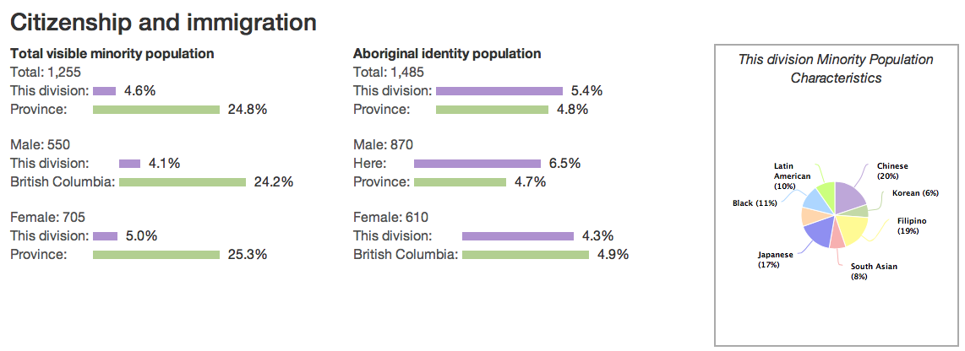
Read more:
http://www.city-data.com/canada/Sunshine-Coast.html#ixzz4c6pSNS9B

CHART 2 - SUNSHINE COAST POPULATION BY AGE GROUP (2011)

CHART ! - RELIGIOUS AFFILIATION (2011)

Total population in private households by religion  National Household Survey data footnote  55 | 28,070
Buddhist | 240
Christian | 11,870
Anglican | 2,590
Baptist | 675
Catholic | 3,190
Christian Orthodox | 120
Lutheran | 550
Pentecostal | 320
Presbyterian | 200
United Church | 1,790
Other Christian | 2,435
Hindu | 40
Jewish | 160
Muslim | 20
Sikh | 25
Traditional (Aboriginal) Spirituality | 100
Other religions | 270
No religious affiliation | 15,340

OARH COMMITTEE MEMBERS
2017.03.21.
Sunshine Coast

- Main Contact:
April Struthers, Consultant
Wit Works Ltd.
c/o Box 1381 Sechelt, BC V0N 3A0
604-885-0651,
witworks@dccnet.com

Contact List of Community Partners that are part of the local OARH community.

1. Name or Name of Organization | 2. Contact person for organization |  | 3. Telephone number |  | 4. Email address | 5. Calendar year they became a Community Partner
RCMP | Cpl. Kris Josephson  Community Officer |  | 604-885-2266  Non-emergency # |  | sunshinecoast.rcmp.ca | 2015
Volunteer  Ex-Town of Gibsons Councilor, Gibsons Seniors Society Director, Social Housing Consultant | Lee Ann Johnson |  | 604-886-0434 |  | leeannj@uniserve.com | 2015
Volunteer  Ex –ED,  Sunshine Coast Community Services  Human Resources Consultant | Lucie McKiernan |  | 604-886-8326 |  | lmckiernan@telus.net | 2015
Volunteer  Consultant, Director  Marketing and Communications  VAKA Marketing Inc. | Ian McDonald | 604-885-3851 |  | imac@vakamarketing.com |  |  | 2016
Volunteer  Consultant , Director  VAKA Marketing Inc. | Jane McDonald | 604-885-3851 |  | jsmacdonald10@gmail.com |  |  | 2016

Restorative Justice Program of the Sunshine Coast | John Denham | 604-885-7373 | http://www.rjpsc.ca  rjpsc@eastlink.ca | 2016
Restorative Justice Program of the Sunshine Coast | Nancy Denham | 604-885-7373 | http://www.rjpsc.ca  rjpsc@eastlink.ca | 2016
Capilano University  Literacy Outreach Coordinator  Program Manager, Sunshine Coast Welcoming Communities  Coordinator,  Community Development and Outreach | Sandy Middleton | 604-885-9310  604-989-4273 (cell) | smiddle@capilanou.ca | 2017
Sunshine Coast Community Services  Settlement & Outreach Coordinator  Welcoming Communities | Maria Giltrow | 604-885-5881 | welcome@sccss.ca | 2017

APPENDIX A

Sunshine Coast

Critical Incident Response Protocol

Whereas

We believe that it is desirable for all residents of the Sunshine Coast to enjoy the privileges of living within a free, welcoming, inclusive, and civil community; and We believe that no resident or visitor to the Sunshine Coast ought to suffer from the effects of harassment, intimidation, threat, hateful actions, physical injury, damage to their property, or other forms of violence which are motivated by bias. This includes, but is not limited to, any bias based upon their race, religious belief or non-belief, cultural origin, ethnic origin, perceived or actual sexual orientation, gender or gender identity, economic status, disability status, or social status; and We believe that it is the duty of all residents, acting individually and together, to strive for the achievement of a community in which we acknowledge our diversity by affirming our differences and welcoming the contributions that arise from each resident’s unique gifts; and We believe that every resident has the right to experience the sense of belonging to this community that arises from our daily commitment to creating a better world.

Therefore

As authorized representatives of the governments, agencies, and organizations named, we accept and agree to work towards the effective implementation of policies and practices within our respective governments, agencies, and organizations that recognize, affirm and encourage the inclusion of all; and we commit our governments, agencies and organizations to the implementation of the integrated responses to racist, homo/transphobic and hate-based critical incidents which are the subject of this Protocol; and we encourage all residents and visitors to the Sunshine Coast to welcome and engage with each other in ways that incorporate the principles of inclusion, affirmation of difference, and broadening our understanding of one another so that these principles shall be evident in the ways in which we live and work together

APPENDIX B

Signatories

Governments, Boards, Agencies, Organizations, groups and individuals that signed the protocol on March 21st, 2017 (The International Day for the Elimination of Racial Discrimination).

OARH Committee

Cpl. Kris Josephson, RCMP

Lee Ann Johnson

Lucie McKiernan

Ian McDonald

Jane McDonald

John Denham

Nancy Denham

Sandy Middleton

Maria Giltrow

APPENDIX C

District of Sechelt Declaration

Vision

The District of Sechelt and its citizens value and respect individual differences and are welcoming and inclusive to people of all ages, cultures, economic levels and abilities
-outdoor spaces, buildings and services are accessible:
-people are informed, connected, included and integrated
-there is a full range of safe and accessible transportation options and
-housing is adaptable, affordable, pleasing and close to amenities

Community Accord: Sunshine Coast

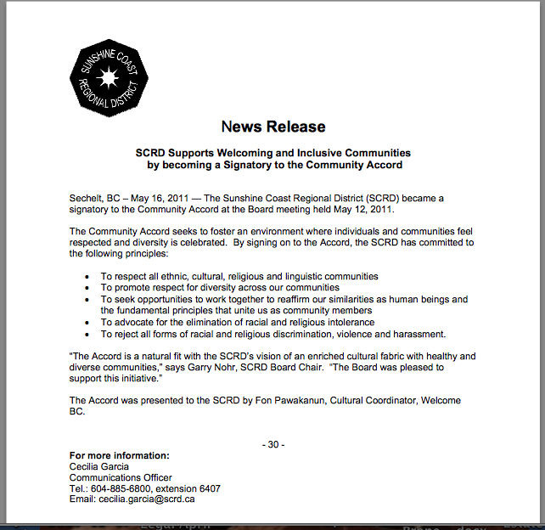

APPENDIX D Statutory Provisions

These documents are available at: Universal Declaration of Human Rights http://www.un.org/en/universal-declaration-human-rights/

Part 1 of The Constitution Act, 1982 (Canadian charter of rights and freedoms) http://laws-lois.justice.gc.ca/eng/Const/page-15.html

Canadian Human Rights Act
http://laws-lois.justice.gc.ca/eng/acts/H-6/

British Columbia Human Rights Code
http://www.bclaws.ca/Recon/document/ID/freeside/00_96210_01

In Canada and in each territory and province, there are Acts and Codes that govern and enforce the rights of Canadians under the law.

Under The Canadian Charter of Rights and Freedoms and The Canadian Human Rights Act, all Canadians are to be free of discrimination and have rights to protection and benefits under the law regardless of race, national or ethnic origin, colour, religion, sex, age, or mental or physical disability.

The Citizenship Act stipulates that all Canadians by birth or choice have equal status, rights, powers and privileges and the same obligations, duties, and liabilities.

The Canadian Multiculturalism Act recognizes the diverse cultures that make up Canadian society and secures their rights to preserve and enhance this multicultural heritage while working to achieve economic, social, cultural, and political equality.

In British Columbia, these rights are protected and enforced under the BC Human Rights Code through the BC Human Rights Tribunal. These codes recognize that human being are equal in worth and dignity and have rights to the same freedoms, which includes freedom from discrimination on the grounds of race, colour, ancestry, sex, pregnancy, sexual orientation, civil, marital or family status, age, religion, political belief, language, ethnic or national origin, social condition, or disability. In BC, if a person has a complaint, the BC Human Rights Clinic can advise you. A complaint would be filed with the BC Human Right Tribunal.

Under the Criminal Code, a hate-bias crime is a criminal offence committed against a person or property which is motivated by the suspect’s bias, prejudice or hate against an identifiable group based on race, national or ethnic origin, language, colour, religion, sex, age, mental or physical disability, sexual orientation or any other similar factor.

In British Columbia, the BC Hate Crime Team has a mandate to identify, investigate and prosecute hate-motivated crimes. Police and Crown Council work hand in hand to fulfill this mandate. In consultation with stakeholders and community groups, they developed a policy guide that outlines their roles and responsibilities.

Retrieved from Respect Network Thompson – Okanagan, BC March 21, 2017
http://www.respectnetwork.ca/index.php/understanding_racism_hate/

APPENDIX E Glossary of Terms

CIRM Tool Kit Excerpted from: www.mcaws.gov.bc.ca (commpartnerships.indd)






A N T I - R A C I S M & H A T E

C R I M E




Terminology Guide

The list of terms is not exhaustive and many debates exist about how these terms can be deﬁned.

Ministry of Community, Aboriginal and Women’s Services

This terminology guide is designed to help people work together to prevent and respond to racism and other types of hate activity. Terms like “prejudice” and
“discrimination” are defined to assist you in a discussion about these issues. At the end of this guide is a list of sources that have been used for the definitions.
The list of terms is not exhaustive and many debates exist about how these terms can be defined. This guide has been created as only a starting point for discussion and for you to consider the terminology you may want to use. You can learn a lot about the people you are working with, and yourself, by discussing terms and – if you have time
– Agreeing on your own definitions of important words and phrases.

Section I: Words related to attitudes and beliefs

Race is a social construct that divides people into groups, based on physical characteristics (such as skin colour, etc.), origin or ancestry. This term raises debates. Many people state that ‘race’ is meaningless and the acceptance of it as a legitimate category has been harmful. Instead, some people have used the word ‘ethnicity’ or ‘ethnic identity’ (these are used interchangeably). In human rights law the word ‘race’ is used because the courts have determined that what is important is not the actual physical characteristic of a person, but how the perpetrator perceives the person.

Ethnicity refers to a person’s cultural background, including language, origin, faith and heritage. Ethnicity comprises the ideas, beliefs, values and behavior that are transmitted from one generation to the next.

Ethnicity is also a concept created by society and is perceived in terms of common culture, history, language or nationhood.

Racism is a set of mistaken assumptions, opinions and actions resulting from the belief that one group of people categorized by physical characteristics or ancestry is inherently superior to another. Racism can happen one on one, or groups, organizations or institutions may practice it. It can take many forms, including:

Stereotyping refers to a belief that certain people are exactly the same, just because they have some things in common (like their skin colour, origin or ancestry).

Prejudice preconceived judgment or assumption, not based on any facts or evidence, towards an individual or group that results in treating that individual or group as inferior or different. It is similar to stereotyping.

Bias is an inclination or preference based on something other than facts or evidence.

Intolerance is a lack of acceptance or respect for people from diverse backgrounds, beliefs or practices.

Section II: Words related to actions

Hate Activity is any expression of hate or hostility towards a group or individual, based on things such as race, gender, religion, sexual orientation, or ethnicity.

Hate Crime is a criminal offence, motivated by a person’s hate, prejudice or bias against an identifiable group or individual. This includes, for example, people who share a common language, ethnicity, skin colour, gender, age or religion.

Hate Propaganda is a type of hate crime. Spoken or written words that encourage or promote hate, dislike, or harm towards a person, a specific group or groups.

Discrimination happens when people are treated unfavorably because of prejudice, especially prejudice based on things like race, gender, class, religion, age, disability, sexual orientation, or ethnicity.

Oppression is unjust or cruel treatment, usually designed to keep people from gaining or using power.
Oppression can include physical, psychological, social or economic threats, or the use of actual force.

Harassment is the act of annoying, insulting, or treating someone badly. It can include such things as name-calling, jokes, insults or general rudeness.

Marginalization happens when a person or group is considered unimportant, their voices and views are ignored and they do not have full equal access to the social, economic, cultural and political institutions of society.

Section III: Words related to anti-racism

Anti-racism is the practice of identifying, challenging, preventing, eliminating, and working to change the ideas and values (such as prejudice, bias and stereotypes) that contribute to racism.

Cross-cultural understanding knowledge and awareness gained by interacting with people from diverse cultures without imposing one’s own cultural values on someone.

Diversity means variety. When we talk about anti-racism, diversity refers to the range of unique qualities that all people have as individuals. It recognizes that we are all different, and that our differences can be a source of strength.

Inclusive describes any effort to include people
– regardless of their differences. For example, inclusive language uses terms like “police officer” rather than “police man” so that women aren’t excluded. Inclusive organizations have policies and practices that respect peoples’ differences, such as hiring employees who reflect their communities’ diversity.

Equality is about treating everyone the same. For example, Canadians are equal under the law. We all have the same rights and responsibilities, regardless of our differences.

Equity is about fairness. It involves accommodating differences and recognizing that some people may face barriers or disadvantages in areas like employment.

Mosaic is a picture or pattern made of many different pieces that all fit together. The term is often used to describe Canadian society and communities because they include many people from many different backgrounds, all working together.

Multiculturalism is the recognition that people of all diverse backgrounds and cultures contribute to, and enrich, a community or society. It promotes a cross-cultural understanding and respect of all diverse cultures.

Sources**

- American Psychological Association [August 2002], Guidelines on multicultural education, training, research, practice, and organizational change for psychologists, www.apa.org/pi/ multiculturalguidelines/de fi nitions.html.

- B.C. Human Rights Coalition [February 2003], Responding to incidents of racism and hate: a handbook for service providers, pp. 2-10; 28-32.

- Jay, G. Dr. [December 2002], What is multiculturalism? University of Wisconsin: Milwaukee, www.uwm.edu/
~gjay/Multicult/Multiculturalism.html

- Ministry of Community, Aboriginal and Women’s Services: Aboriginal, Multiculturalism and Immigration Programs Department [March 2003], Future directions: setting the path for anti-racism and multiculturalism programming in British Columbia, Steering Committee Report, pp. 19-21.

- PBS [April 2003], Race: the power of an illusion, 3- part documentary about race in society, science and history, www.pbs.org/race

- Pincus, F. L. and H. J. Ehrlich [1994], Race and ethnic conflict: contending views on prejudice, discrimination, and ethnoviolence.

**All definitions were adapted and written from sources 2 and 4. The other sources were consulted for additional information.

